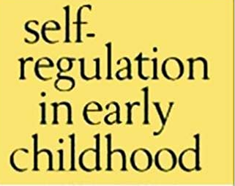
How self-regulation develops
Babies aren’t born with the ability to control their own reactions and behavior.
Babies
Your baby is too young to learn self-regulation, but with your help he’ll start developing ways of handling his emotions.
When you respond quickly to your baby when she’s upset, and cuddle and comfort her, she calms down. learning self-regulation.
Toddlers
As your baby becomes a toddler he’ll start to develop some basic self-regulation skills.
From around two years your child will probably be able to follow simple instructions or rules like ‘Please put your hat on’ and ‘Don’t hit’.

What is self-regulation?
Self-regulation is the ability to understand and manage your behavior and your reactions to feelings and the things happening around you.
It includes being able to:
• regulate reactions to emotions like frustration or excitement
• calm down after something exciting or upsetting
• focus on a task
• refocus attention on a new task
• control impulses
• Learn behavior that helps you get along with other people.

Behavioral Child
Development Theories
Two important types of learning that emerged from this approach to development are that classical conditioning and operant conditioning. Classical conditioning involves learning by pairing a naturally occurring stimulus with a previously neutral stimulus. Operant conditioning utilizes reinforcement and punishment to modify behaviors.

Why self-regulation is important?
• learn at school – for example, because self-regulation gives her the ability to sit still and listen in the classroom
• behave in socially acceptable ways – for example, because self-regulation gives her the ability to control impulses
• make friendships – for example, because self-regulation gives her the ability to take turns in games, share toys
• become more independent – because self-regulation gives her the ability to make good decisions about her behavior

References
Palmer, J.A. (1998) Environmental Education in the 21st Century. Theory, Prac-tice, Progress and Promise: Routledge, London.
Prawat, R.S. (1990) Changing Schools by Changing Teachers’ Beliefs aboutTeaching and Learning. Michigan State University, Collage of Education,Elementary Subjects Centre Series 19.
Puolimatka, T. (2002) Opetuksen teoria. Konstruktivismista realismiin [Thetheory of teaching. From constructivism to realism]. Helsinki: Tammi.

Tilbury, D. (1995) Environmental education for sustainability: Defining the new fo-
cus of environmental education in 1990. Environmental Education Research

Conclusion

From time to time, different things can affect your child’s ability to self-regulate. For example – tiredness, illness and changes to your child’s routine can all affect her ability to regulate her reactions and behavior. Also, some children have great self-regulation at child care or school but find it hard at home. Other children struggle in busy, noisy places like shopping centers.
Although these problems with self-regulation are pretty normal, it’s a good idea to speak with a professional if you’re worried about your child’s behavior or you’re having trouble managing his behavior as he gets older. For example, you could talk to your GP, your child and family health nurse, or your child’s child care educator or teacher.

